GROWING GOOD NEIGHBORS
Planning Tool Kit
Growing Good Neighbors
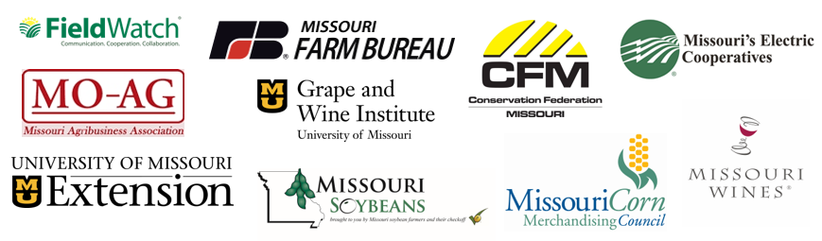

TABLE OF CONTENTS
Project Concept 2
Project Overview Slide 5
Dinner Invitation Sample 6
Sample Dinner Program Run of Show 7
Sample Remarks for Organizers 9
Dinner Discussion Guide 12
One-Pager Handout 13
Post-event Social Media Posts 14
Post-event Newsletter Article/Blog Template 16
Post-event Survey 17
(to be administered through Survey Monkey, Constant Contact or another provider)

Growing Good Neighbors Project Concept

- Situation Analysis
In many FieldWatch states, sensitive and specialty crops and beehives may be growing near traditional row crops. Good communication is essential to ensure applicators are aware of sensitive crop and beehive locations and plan their work accordingly. Facilitating good neighborly relations between ag retailers, grape growers, other sensitive crop growers, beekeepers, conservationists, row crop growers and others can benefit all parties and help avoid costly damages (e.g., loss of crops for sensitive crop growers, legal fees for applicators, potential for costly insurance payments) and loss of trust within the agriculture industry.

- Project Concept
Growing Good Neighbors is a program designed to gather grape growers, retailers, crop growers, livestock producers, beekeepers, specialty crop growers, conservationists and other community members over a shared meal to foster mutual understanding. The program hosts community dinners to discuss issues that impact today’s agricultural communities and uncover common values. The goals of the program are to establish good neighborly relationships, increase communication about crop locations and new technologies, and create resilient communities with a favorable environment.
- Project Goals
- Forge new relationships and foster mutual understanding between diverse members of the agriculture community.
- Identify and strengthen shared values between all parties.
- Map sensitive/specialty crops and beehives to build awareness of their locations.
- Develop trust in a voluntary system for collaboration, such as FieldWatch.
- Minimize risk of damages.

- Key Stakeholders
It is important for the dinner participants to reflect the diversity of today’s agricultural communities:
- Retailers/applicators (management and staff)
- Grape growers
- Row crop growers, particularly those who apply crop protection products independently
- Specialty crop growers
- Beekeepers
- Livestock producers
- Rural electric coops
- Conservationists
- Agritourism operators
- University extensions
- Local Farm Bureau chapters
- FFA teachers
- Others interested agriculture/community stakeholders
- Desired Outcomes
- Increased stewardship in the field.
- Increased awareness of crop locations and spraying times to avoid the potential for drift incidents.
- Communication of success stories showcasing good neighborly relationships that lead to improved coexistence of various agricultural practices within communities. Distribution of resulting videos, photos, social media posts, blogs, etc. through the participants’ channels.
- Best practices and toolkits that can be replicated elsewhere.

- Tentative Timeframe
Example: Fall – Winter 2018/2019

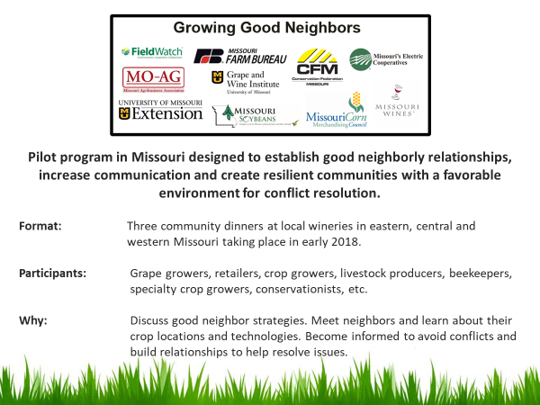
Sample Dinner Invitation
Growing Good Neighbors
You and a Guest
Are Invited to Dinner
Thursday, February 8th
6 p.m. – 8 p.m.
St. James Winery
540 State Route B
St. James, Mo. 65559
Please RSVP to ___________ by _____________
Childcare will be provided
Growing Good Neighbors is a pilot program designed to gather grape growers, retailers, crop growers, conservationists and others over a shared meal to foster mutual understanding. The program will host several community dinners to discuss issues that impact today’s agricultural communities and uncover common values. The goals of the program are to establish good neighborly relationships, increase communication about crop locations and new technologies, and create resilient communities with a favorable environment for conflict resolution.
Organizations Supporting Growing Good Neighbors are:
Missouri Farm Bureau • Missouri Wine and Grape Board • Missouri Agribusiness Association •
Conservation Federation of Missouri • FieldWatch •
Missouri Corn Merchandising Council • Missouri Soybean Association • Association of Missouri Electric Cooperatives •  University of Missouri Extension • University of Missouri Grape and Wine Institute

GROWING GOOD NEIGHBORS
Sample Dinner Program Run-of-Show
Action | Time | Responsible | Supplies/Materials Needed | Notes
Setup | 4:45 p.m. – 5:40 p.m. | Organizer | - Registration table  - Name tags  - Seating assignments  - Question sheets for table activity  - Table tents with table numbers  - Podium/microphone?
Doors Open/Registration | 5:45 p.m. | Organizer | - Name tags  - Seating assignments
Childcare Opens | 5:45 p.m. | Childcare contractor | - Crayons  - Coloring books  - Movie/DVD player  - Pillows/blankets?  - Food/drink? | Food allergy waivers; liability waivers
Welcome, Opening Remarks | 6:00 p.m. – 6:05 p.m. | Organizer/Moderator | - Script/talking points
Local Contact Remarks | 6:05 pm. – 6:10 p.m. | Dinner Host | - Brief Organization overview  - Welcome to participants
Round-robin introductions | 6:10 p.m. – 6:35 p.m. | Moderator | - Keep it very brief  - Need 3 things: Name, occupation, location | Reminder that more opportunity will be given shortly for expanded conversations – the how’s and why’s.
Group Activity explained; tables dismissed by numbers to buffet | 6:35 – 7:30 p.m. | Moderator | - Explanation of activity with an example given.  - Draw their attention to the sheets lying face down on table.  - Ask the tables to spend a little more time introducing themselves  - Then work together through the questions on the sheet.  - One person should be prepared to share an example they agree upon with the whole group in an approximately 2-minute presentation.  - Moderator, dinner host move between tables to help facilitate, if needed.  - Verbal cue given 10 minutes after the last of the attendees move through the buffet that the tables should be discussing the questions.  - Verbal cue given when on 10 minutes remain before table presentations. | Possible questions on activity sheet:  - Do you know your neighbors? If not, why?  - What are some of the benefits of having relationships with neighbors  - Share an example when a lack of a neighborly relationship caused a conflict or when the existence of a relationship avoided or lessened a conflict.
Table presentations | 7:30 p.m. – 8 p.m. | Leaders from each table.
Closing Remarks | 8:00 p.m. – 8:05 p.m. | Moderator/Event Organizer | - Direct to table as they leave for handouts  - Mention e-survey that they are asked to fill out

Follow-up:
- Send e-mail thanking guests for their participation and include brief survey asking for their impressions of the program.
GROWING GOOD NEIGHBORS
Sample Dinner Remarks for Organizers

OPENING REMARKS – 6:00 – 6:20 p.m.
Organizer:
3 min.
- Good evening. Personal introduction and brief introduction of [organization convening the dinner].
- Thank you for spending your evening with us. We are excited to welcome you to this Growing Good Neighbors dinner.
- Growing Good Neighbors is a program that brings together a diverse group like the one we have in the room, made up of grape growers, retailers, crop growers, conservationists and others over a shared meal to foster mutual understanding.
- In rural communities, good relationships between neighbors are key – they lead to open communication, increased awareness and the ability to resolve conflicts amicably, if and when they arise. We hope that at the end of the evening, you will walk out of here knowing your neighbors and your community a bit better.
- This is meant to be an informal event and we hope you participate in the conversations as much as you are comfortable. Since we want to be respectful of your time, there will be some structure to the evening and we’ll provide guidance as we move along.
- We are very grateful to [insert name of location] for hosting us here tonight and I’d like to invite [insert name] to say a few words.

Host:
5 min.
- Personal introduction
- Brief history of the hosting organization (e.g., winery)

Moderator:
3 min.
- Personal and organization intro (e.g., FieldWatch).
- Thank you for introducing the program, and [location owner] for hosting us.
- Growing Good Neighbors is a collaborative effort and I’d like to thank all the organizers whose logos are listed on your tables (one pager) for their support and participation.
- As you all know, in agriculture, we are technology adopters. In fact, FieldWatch, the organization I represent was created as a technology platform to connect technology users in agriculture. Growers or sensitive crops and beekeepers can enter information about their field locations that can be accessed by applicators to ensure good stewardship. But we also know that agriculture is an industry built on human relations. We can’t rely only on technology to communicate with our neighbors.
- That’s why it’s so important that we are good neighbors to each other. I learned this first hand… [Include personal example]
- In rural communities, there are many issues that give us opportunities to be good neighbors and some that can cause conflicts. Drug abuse, respecting property lines, cattle wrestling and the introduction of new products, like dicamba, can cause tensions. We are not here today to address every one of these issues, but to have a bigger conversation about what it means to be good neighbors and how good relationships can help avoid costly and unpleasant situations.
- Growing Good Neighbors is a pilot project to test the idea of enhancing communication through direct interactions. The goal is to find an effective way to supplement communication through technology to build trust and promote openness in rural communities.
- We hope that the concept of getting neighbors together takes off on its own, with local organizations and individuals finding formats to engage directly that work for them. Growing Good Neighbors will continue to play a facilitator role, but our hope is that the idea continues to be carried out and amplified by those in ag communities.

Moderator:
2 min.
- A few logistical remarks about the rest of the evening. First, I’d like us to take a few minutes to go around the room to introduce ourselves. Let’s keep it brief because dinner is waiting. Please stand up and say your name, where you live and what you do and what your interest in being here.
- After the introductions, dinner will be served and then you will spend some time meeting or re-connecting with your table mates. This is a chance for you to get to know your neighbors better – where they live, what they do, what crops they grow, etc.
- Then, we have a brief list of questions we’d like to ask you to discuss amongst yourselves to keep the conversation focused. The questions are listed on the sheets in the middle of the tables. We invite you to discuss either an example that shows the benefits of knowing your neighbors or an example when a lack of neighborly relationship caused a conflict. We are asking that you pick one representative from each table to summarize the discussion at the end of the evening.

DINNER
Moderator:
- Call on tables to get dinner.
- Allow 20 minutes for unstructured eating.
- Announce the beginning of the table exercise.
- Call on tables to present their takeaways.

CLOSING (Moderator or Organizer)

- Thank you again for spending your evening with us and for the interesting discussions. We hope you are walking out tonight knowing your neighbors better or having a greater appreciation for a different segment of our industry.
- Don’t forget to take a copy of the handout that was on your chairs.
- We will be following up with a brief email survey. We would love your candid feedback on what we’ve tried to do here tonight. As mentioned, this is a first of its kind initiative and we want to make improvements as we go along.
- We’d encourage you to share about this experience with friends, family and peers and on social media if you are so inclined. Use the hashtag #GrowingGoodNeighbors so we can follow along.
- If you liked the concept of meeting to break bread together and build relationships, we invite you to tell others what you’ve learned and consider starting such events on your own.
- Good night and have a safe evening.

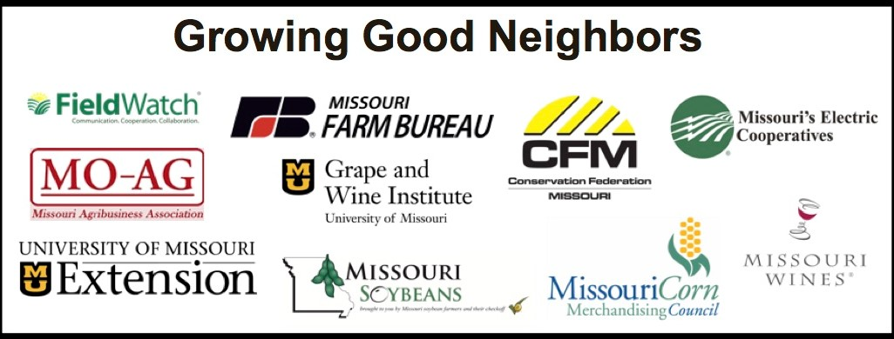
DISCUSSION GUIDE
TO MAKE THE CONVERSATION FLOW EASIER, DISCUSS THE FOLLOWING QUESTIONS AS A GROUP:

- Do you know your neighbors? How did you meet them your neighbors? If you don’t yet know your neighbors, what has prevented you from meeting them?

- What are some of the benefits of having relationships with neighbors?

- Share an example of when:
  - neighborly relationships avoided or lessened a conflict or
  - how you have relied on or could rely on your neighbors

ASSIGN ONE PERSON TO PROVIDE A BRIEF SUMMARY OF YOUR DISCUSSION TO THE ENTIRE GRUP.

THANK YOU FOR ATTENDING TONIGHT’S DINNER

Growing Good Neighbors is a pilot program designed to gather grape growers, retailers, crop growers, livestock producers, beekeepers, specialty crop growers, conservationists and other community members over a shared meal to foster mutual understanding. The program will host several community dinners to discuss issues that impact today’s agricultural communities and uncover common values. The goals of the program are to establish good neighborly relationships, increase communication about crop locations and new technologies, and create resilient communities with a favorable environment for conflict resolution.
Let us know what you think about tonight’s event: check your e-mail tomorrow and fill out our survey
Share your impressions about Growing Good Neighbors on social media using the hashtag #growinggoodneighbors

If you are interested in learning how to host or arrange a Growing Good Neighbors dinner, see our Tool Kit at www.fieldwatch.com/neighbors
For more information, visit www.fieldwatch.com/neighbors to get photos and videos of this event and for further updates

WE HOPE YOU STAY IN TOUCH

Growing Good Neighbors

Post-Event Suggested Social Media Posts:
Facebook:
PICTURES TO BE INSERTED
- XX (ORGANIZATION NAME or We) recently helped host a community at (location) as part of a pilot program in Missouri designed to help build resilient communities. The program – Growing Good Neighbors – is a pilot program that gathers grape growers, retailers, crop growers, conservationists and others over a shared meal to foster mutual understanding. The goals of the program are to establish good neighborly relationships, increase communication about crop locations and new technologies, and create a favorable environment for conflict resolution.

- Have you ever asked yourself what it means to be a good neighbor? Do you know what crops your neighbor is growing and what technologies are used next door? As issues in agricultural communities become more complex, it’s sometimes hard to get to know the people on the other side of the fence row. That’s why (ORGANIZATION NAME or We) helped support a new pilot program in Missouri -- Growing Good Neighbors. The program aims to gather grape growers, retailers, crop growers, conservationists and others over a shared meal to foster mutual understanding. We recently hosted a community dinner at X (location) and more than xx (number of attendees) people came to discuss issues that impact today’s agricultural communities. Turns out, we all have a lot of common values. We were excited to see neighbors establishing or strengthening relationships and talking about things like crop locations and new technologies. That’s what creating resilient communities is all about and it’s how we establish a favorable environment for conflict resolution.

- (ORGANIZATION NAME or We) were recently a proud supporter of the new Growing Good Neighbors pilot program. This program is designed to gather grape growers, retailers, crop growers, conservationists and others over a shared meal to foster mutual understanding. We participated in a community dinner at x (location) in which attendees got to know each other better and learned about each other’s crop locations and technologies.

- Resolving a conflict among neighbors is much easier when they have a relationship built upon trust and mutual understanding. But what does it take to be a good neighbor? We discussed this and other topics with members of the x (community or town name) as part of a new Growing Good Neighbors pilot program designed to foster mutual understanding among neighbors in Missouri. The program gathered grape growers, retailers, crop growers, conservationists and others over a shared meal at x (location) to forge relationships and promote awareness of crop locations and new technologies. We were proud to be a supporter and hope the program continues in the future.

Tweets and Possible Hashtags:
(NOTE: Organizations choosing to post about the Growing Good Neighbors program on their websites are encouraged to link any social media posts to their website content.)

#communication #growinggoodneighbors
#stewardship #collaboration
#ag
What does it take to be a good neighbor in a rural community? A diverse agriculture group shared stories and exchanged opinions at Baltimore Bend Vineyard in Waverly, MO. The consensus: #GrowingGoodNeighbors means open communication. More: www.fieldwatch.com/neighbors.
Character count: 268

Grape, vegetable, crop & cattle growers, retailers, academics, teachers and others gathered for a #GrowingGoodNeighbors dinner to discuss issues that impact their communities. Thank you XX for hosting us.
Character count: 204

In agriculture, communication goes beyond technology. At a #GrowingGoodNeighbors dinner, applicators, beekeepers, teachers, crop & cattle growers, agritourism farmers and others discuss ways to strengthen agriculture communities through open communication. #ag #collaboration
Character count: 275

Proud to have been a supporter of a new #GrowingGoodNeighbors dinner that gathers grape & crop growers, retailers, conservationists & others. #stewardship #ag
Character count: 158

We recently supported the #GrowingGoodNeighbors program by participating in a community dinner that got growers, retailers, conservationists & others talking. #collaboration
Character count: 174

A new #GrowingGoodNeighbors program recently piloted in MO and we helped host a community dinner that got growers, retailers, conservationists & others #collaborating. #MOag #farmers
Character count: 183

A new program recently piloted in Missouri that brought growers, retailers, conservationists & others together for conversation and #collaboration. We were a proud supporter and participant. #GrowingGoodNeighbors
Character count: 213

Proud to support #GrowingGoodNeighbors program that recently gathered growers, retailers, conservationists & others to talk over a shared meal. #collaboration #stewardship
Character count: 171

When growers, retailers, conservationists & others talk, problems resolve. #GrowingGoodNeighbors program is making it happen and we were proud to help make it happen. #mowine #ag
Character count: 178

Growing Good Neighbors Newsletter/Blog Template
(Please adapt as appropriate)
XX (Org. Name) Helps Host Program [pick your preferred option for a title, or create your own] for Building Resilient Agriculture Communities

Recently, xx (organization name) took part in a pilot program designed to help build resilient rural communities in Missouri. Growing Good Neighbors is a pilot program that gathers grape growers, retailers, crop growers, conservationists, beekeepers, academics, teachers and others over a shared meal to foster mutual understanding.
In rural communities, there are many issues that give us opportunities to be good neighbors and some that can cause conflicts. Drug abuse, respecting property lines, cattle wrestling and the introduction of new products, like dicamba, can cause tensions. Conflicts are addressed more productively when there is trust and open communication. The dinners aimed to create a relaxed atmosphere conducive to a bigger conversation about what it means to be good neighbors and how good relationships can help avoid costly and unpleasant situations.
[Insert quote from organizing member]. “XX organization represents the interests of xx and our members understand that as communities change due to [insert reason pertinent to your industry], it is important to learn about each other’s [select what applies] businesses/operations/crops so we can be successful together,” said xx, [title of organizing committee representative.]
“We are so appreciative of the support given to this effort by xx (organization name),” said Stephanie Regagnon of FieldWatch, the convener of the Growing Good Neighbors program. “In the agriculture community, we are quick adopters of innovation and new technologies, yet we still rely on the power of an old-fashioned handshake to build trust,” said Regagnon. FieldWatch is a non-profit company that helps applicators, growers of specialty crops and beekeepers communicate about the locations of crops and hives to improve stewardship
The three dinners -- held at xx, xx and xx -- launched conversations about issues that impact today’s agricultural communities and helped the attendees uncover common values and foster mutual understanding. XX (organization’s name) hopes this will help create resilient communities with a favorable environment for conflict resolution.
[Insert quote from organizing member} “Whether it’s location of sensitive crops, or pesticide applications, resolving conflict among neighbors is much easier when they’ve met and have a relationship built upon trust,” or “It was encouraging to see so many diverse members of our community come together in one place and talk about issues that concern them,” said xx (last name).
Xx (name of organization) hopes the program can continue. If you are interested in bringing this program to your area or becoming involved with the program, visit www.fieldwatch.com/neighbors.

Growing Good Neighbors Post-Event Survey

Thank you for participating in the Growing Good Neighbors dinner last night. We hope you enjoyed your evening. We certainly enjoyed our time with you! We would appreciate your candid feedback as we work to improve this program and make it as meaningful as possible. Also, please remember to visit the website: www.fieldwatch.com/neighbors where we’ll upload photos from last night and use the hashtag #GrowingGoodNeighbors if you have any photos or thoughts to share on social media!

Event Purpose
1. Did you find value in the Growing Good Neighbors Program?
☐ Yes
☐ No
2. Do you feel as though you understand the goals of the Growing Good Neighbors Program?
☐ Yes
☐ No
3. Did you have ample opportunity to share your opinions and/or concerns?
☐ Yes
☐ No
4. Do you know more about your neighbors after attending the dinner?
☐ Yes
☐ No
If yes, what:

5. Did you learn something about crop locations or technology used in your community that you did not previously know?
☐ Yes
☐ No
6. Will you tell others about what you learned?
☐ Yes
☐ No

Event Organization and Logistics
7. Was the event well organized?
☐ Yes
☐ No
8. How was the length of the event?
☐ Too long
☐ Just right
☐ Too short
9. How far did you have to travel to attend?

10. How interesting was the program? (1-5 rating scale: 1=not interesting, 5=very interesting)
11. How would you rate the venue? (1-5 rating scale: 1=not very good, 3=neutral, 5=the best)
12. How would you rate the dinner? (1-5 rating scale: 1=not very good, 3=neutral, 5=the best)
13. Was the availability of childcare a factor in determining your attendance?
☐ Yes
☐ No
14. Additional Comments:

15. Contact Information
Your Name
Organization
Address
Address 2
City
State
ZIP/Postal Code
Email Address
Phone Number

